

Yr11 – 12 Transition Activities
Subject:

Yr11 – 12 Transition Activities
Subject: A level English Literature

THE City of Leicester CollEge

A Level English Literature Information and transition
Course overview
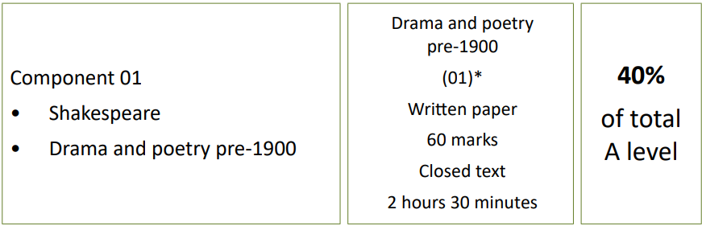

Key texts: Hamlet by William Shakespeare, A Doll’s House by Henrik Ibsen and the Collected Poetry of Christina Rossetti
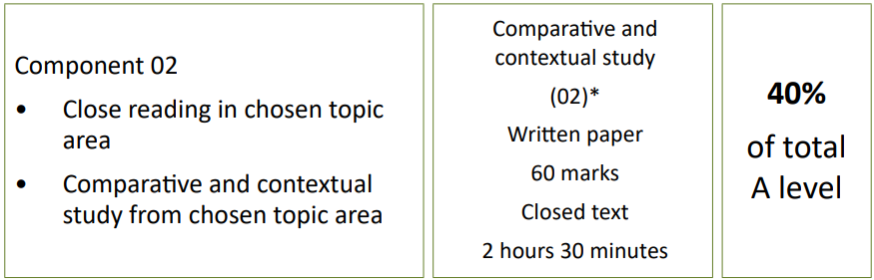

Key texts: Nineteen Eighty-Four, George Orwell and The Handmaid’s Tale, Margaret Atwood
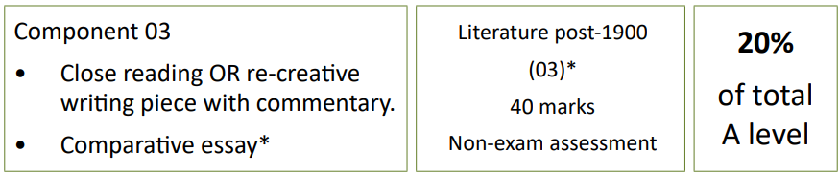

Key texts: Purple Hibiscus by Chimamanda Ngozi Adichie, Ariel by Sylvia Plath and A Streetcar Named Desire by Tennessee Williams
Summer Transition Activities
‘Making the leap’ booklets. Use these to get ready for A Level learning. There are 24 activities – please choose 5 to work on over the summer. We will ask to see these when you start the course. All of the activities are useful, so don’t feel limited to just 5!
Access to platforms:
- emag UN= TCOLCEnglish PW + TCOLCEnglish 2023 (Please DO NOT share this!)
- National Theatre – is free, but you need to sign up yourself.
- Digital Theatre+ - you can login with your school email and password
- Massolit - go to www.massolit.io/users/sign_up and follow the instructions for sign up.

Suggested reading list for Dystopian Fiction
H G Wells: The Time Machine
Aldous Huxley: Brave New World
Ray Bradbury: Fahrenheit 451
Anthony Burgess: A Clockwork Orange
J G Ballard: The Drowned World
Doris Lessing: Memoirs of a Survivor
P.D. James: The Children of Men
Octavia Butler: Parable of the Sower
Cormac McCarthy: The Road

